Title of the Contribution
First Author^{1*}, Second Author², Third Author²
¹Institution, Department, Country
²Institution, Department, Country
*example@email.com

Write your abstract here. Please respect the indicated font type (Arial) and size in title, author list, affiliations and abstract text. [1] The maximum abstract length is one page including references and figures. [2]
We suggest a single line spacing. The references are font size 10, using the Phys. Rev. Lett. style for bibliography. [3]

Lorem ipsum dolor sit amet, consectetur adipiscing elit. Curabitur vitae est at orci congue facilisis. In at sapien non elit blandit feugiat. Pellentesque euismod neque sit amet diam sollicitudin, vitae gravida orci porta. Vestibulum ante ipsum primis in faucibus orci luctus et ultrices posuere cubilia curae; Quisque ut magna at augue aliquam pretium. Sed vitae lacus nec metus fermentum sodales non id elit. Nam at tincidunt lectus, vitae pulvinar purus. Vivamus vulputate enim in justo laoreet, non bibendum elit cursus. Nullam sed sapien sed tortor imperdiet aliquam.
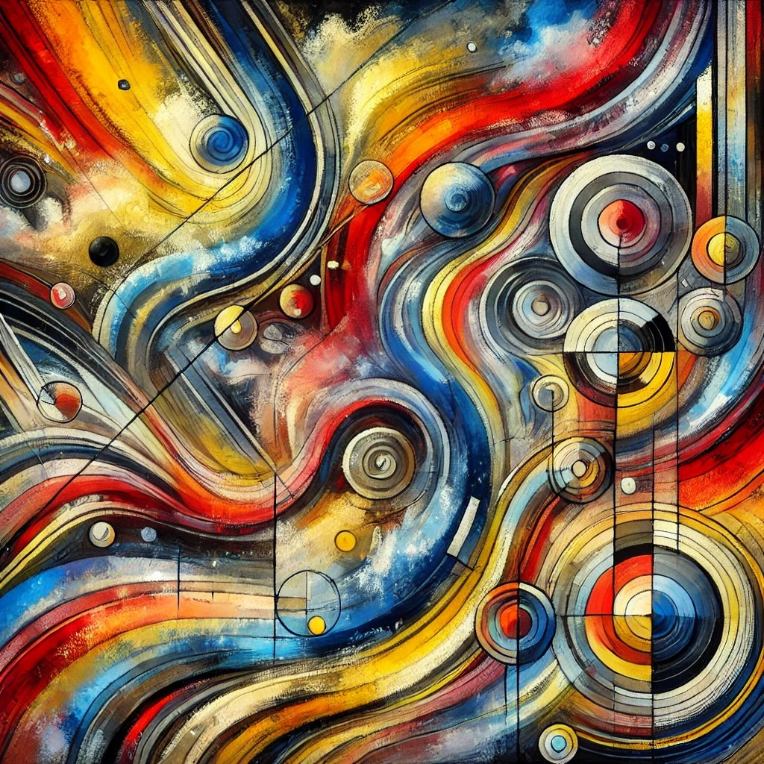
Figure 1. Caption of the figure, change the size, aspect ratio, and position of the text box including your figure and caption as you may require.
Duis nec turpis risus. Sed a convallis velit, at fermentum lacus. Suspendisse potenti. Integer lobortis ligula in diam tristique, et cursus ante bibendum. Phasellus iaculis, sapien sed ultrices fermentum, nunc elit luctus elit, nec tincidunt nibh justo ut ipsum. Proin elementum viverra dolor a pulvinar. Cras nec orci nec eros dapibus tincidunt. Aenean at dui sit amet lorem laoreet cursus non et justo.

References
[1] V. Weisskopf and E. Wigner, Berechnung der natürlichen Linienbreite auf Grund der Diracschen Lichttheorie, Z. Für Phys. 63, 54 (1930).
[2] R. H. Brown and R. Q. Twiss, Correlation between Photons in two Coherent Beams of Light, Nature 177, 27 (1956).
[3] C. K. Hong, Z. Y. Ou, and L. Mandel, Measurement of subpicosecond time intervals between two photons by interference, Phys. Rev. Lett. 59, 2044 (1987).

